Chip back potential is the level which bulk silicon is maintained by on-chip connection, or it is the level to which the chip back must be connected when specifically stated below. If no potential is given the chip back should be isolated.

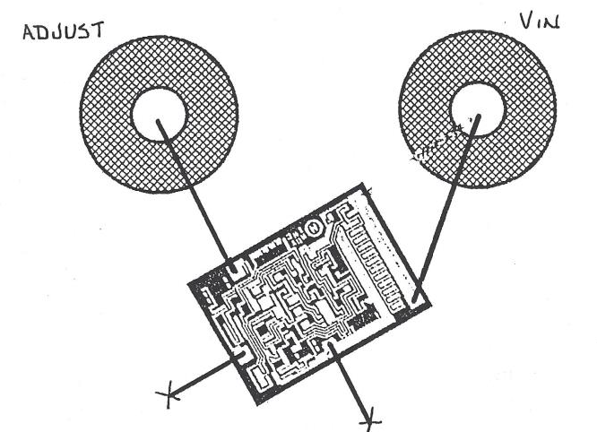

Top Material: Aluminum
Backside Material: Silicon
Bond Pad Size: .004” Square
Backside Potential:
Mask Ref: MG-157

APPROVED BY: DK DIE SIZE .045 x .064” DATE: 1/3/17
MFG: Motorola Semi THICKNESS .015” P/N: LM117L
DG 10.1.2

Rev B, 7/1

